Service Unit 70-11 Thinking Day
for all Girl Scout Levels
A money earning event by Cadette Troop 6863 for Savannah Trip 2016.
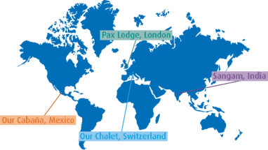
Friday, February 20, 2015
7pm – 8:30pm
Potowmack Elementary School Cafeteria
46465 Esterbrook Circle, Sterling, VA 20165

“We can create peace through partnerships”

✓ Have a great time learning about the 5 WAGGGS Regions
✓ Earn the official WTD Patch through WTD activities
✓ $10 per girl registration includes the patch
✓ Please have each girl bring a small monetary donation for the Juliette Low World Friendship Fund, just some change or a dollar can go a long way. We will discuss this fund as it associates with WTD and WAGGGS during the event.

*Only 1-2 registered adults must to stay to shepherd the troop
*The adult staying is responsible for having permission slips and health histories for all girls in attendance, we will be taking a group photo to share for #guidinglight GS social media movement so obtain permission to photograph.
*Questions about the event should be directed to Tiffany Moore @ nursetiffany@gmail.com.
------------------------------------ Detach and return with registration fee --------------------------------------

Leader/Adult in Charge:

Email:

Phone: Troop#: Level:

# of girls attending: x $10 = $_

Food allergies?

Register by February 13, 2015
Make checks payable to: Girl Scout Troop 6863
Mail to: Tiffany Moore 20966 Promontory Square, Sterling VA 20165 or drop by and place in screen door if I am not home

