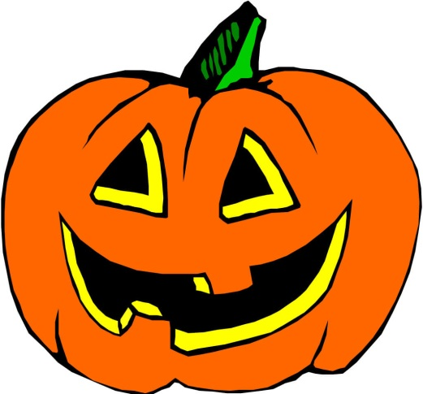
Spooktacular Campout, Oct 6/7 Hockey Game, Oct. 20th
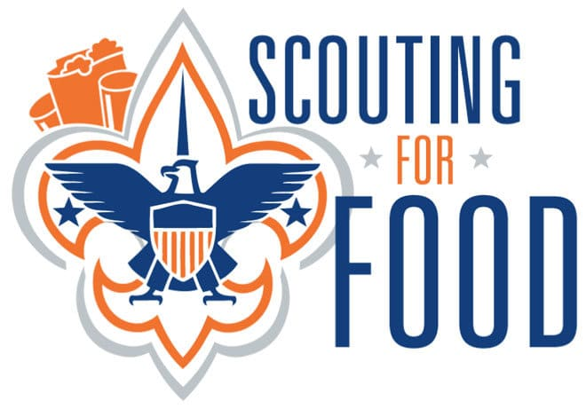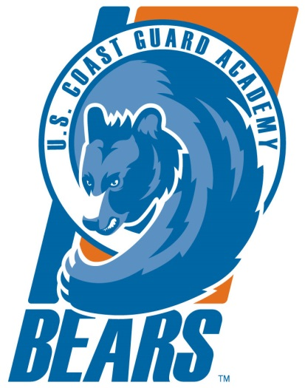
Service Project, Oct. 27 and Nov 3rd Football Game, Nov 3rd
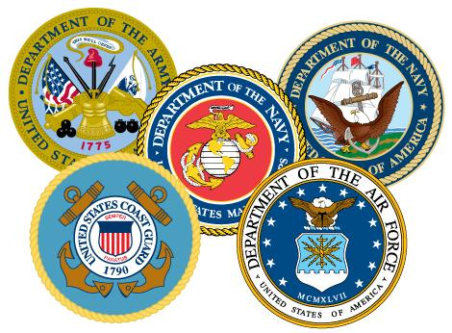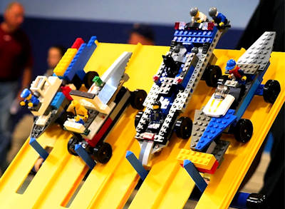
Veteran’s Day Parade, Nov 11th Brick Derby, Dec 1st

