Cotton T shirt $8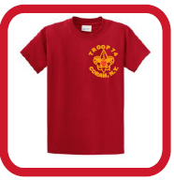  Troop 74 Coram New York |  | Long Sleeve T shirt $12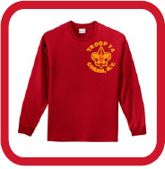 |  |  |  | Red Hooded Sweatshirt $23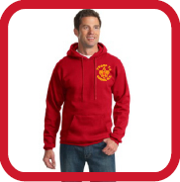 |  |  | Red Zippered Sweatshirt $24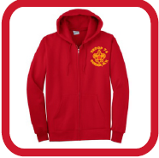
Ladies Fit T shirt $10 |  | Elastic Hem Sweatpants $17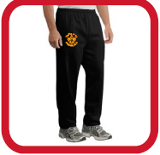 |  |  |  | Open Hem Sweatpants $17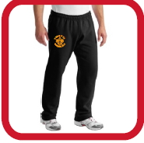 |  |  | Black Thermal Sweatshirt $45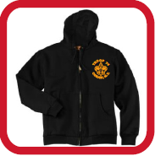
Item | Adult S | Adult  M | Adult  L | Adult  XL | 2XL  Add $3 |  | 3XL  Add $4 | Personalization Add $5  PLEASE WRITE OUT |  | Price
Cotton t shirt
Long sleeve t shirt
Hooded sweatshirt
Zipper sweatshirt
Ladies fit t shirt
Elastic hem sweatpants
Open hem sweatpants
Thermal sweatshirt
Grand Total
$______________
Please make checks out to GRAPHIC INNOVATIONS
Name:________________________________________________________________________
Phone_________________________________

